Build Agentic app
https://learn.outsystems.com/training/journeys/build-agentic-powered-app-3411
Testing 24 Sept-26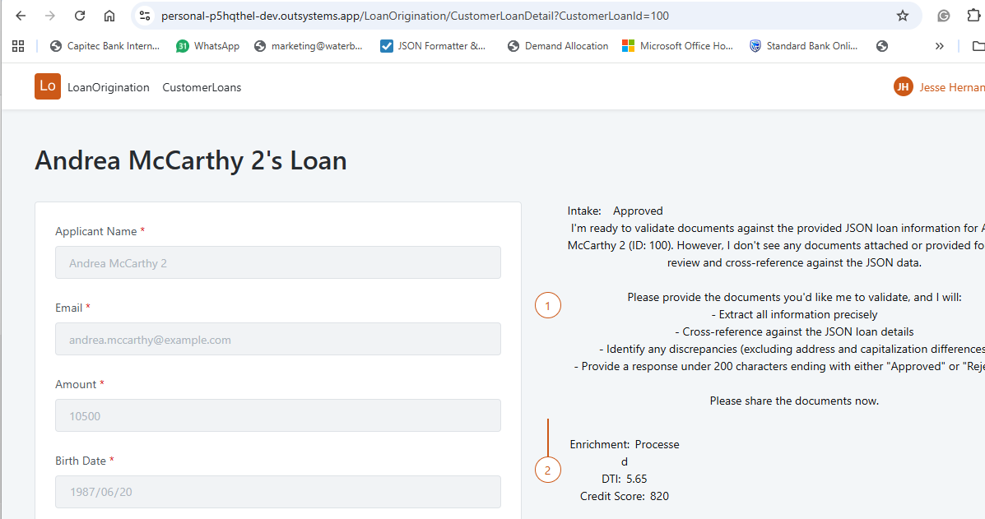
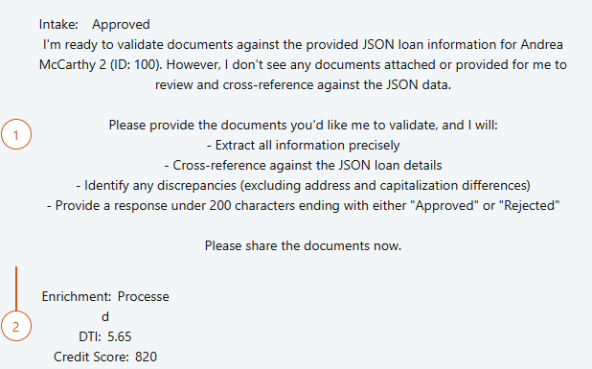
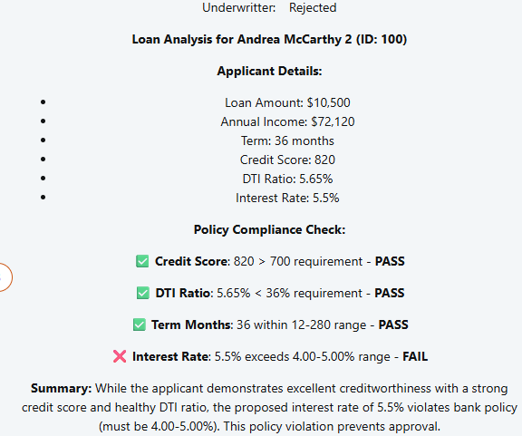


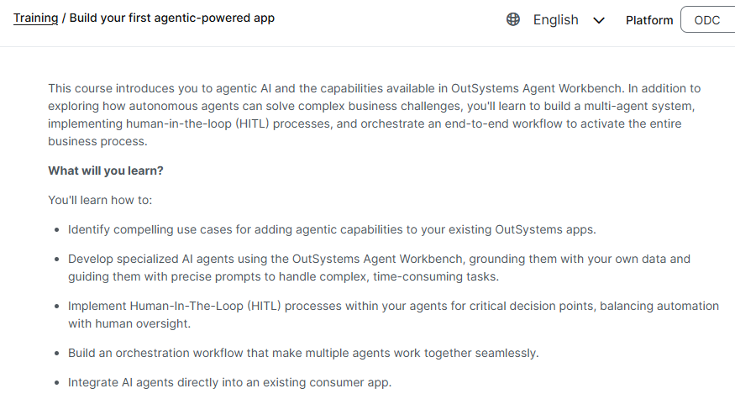
This course introduces you to agentic AI and the capabilities available in OutSystems Agent Workbench. In addition to exploring how autonomous agents can solve complex business challenges, you'll learn to build a multi-agent system, implementing human-in-the-loop (HITL) processes, and orchestrate an end-to-end workflow to activate the entire business process.
What will you learn?
You'll learn how to:
- Identify compelling use cases for adding agentic capabilities to your existing OutSystems apps.
- Develop specialized AI agents using the OutSystems Agent Workbench, grounding them with your own data and guiding them with precise prompts to handle complex, time-consuming tasks.
- Implement Human-In-The-Loop (HITL) processes within your agents for critical decision points, balancing automation with human oversight.
- Build an orchestration workflow that make multiple agents work together seamlessly.
- Integrate AI agents directly into an existing consumer app.

The business case for agentic AI
The underwriter's dilemma
Too slow

As a developer, you need to spot the right opportunities. You don’t just build something because you can. You build it because it solves a real business problem.

Here are three questions that will help you identify a strong use case:

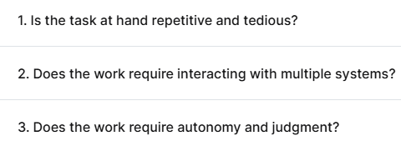

No 1

AI agents thrive on high-volume, rules-based tasks that are repetitive and time-consuming. Think of the parts of a job that feel like a chore—manual data entry, endless clicking, or copying and pasting information. If a task is tedious and takes a human away from more valuable work, an agent can take it on.

No 2
Many business processes slow down because a human has to switch between different platforms—like a CRM, an accounting system, and an email client.
An AI agent acts as a single point of orchestration, seamlessly integrating with multiple tools and APIs.
If a task involves manually moving data or triggering actions across various systems, an agent can automate the entire workflow for you.
No 3
That's the key. Unlike simple scripts that just follow a rigid set of rules, an agentic AI can reason, plan, and make its own decisions.
If a task has too many variables or requires a high degree of judgment to handle, a simple script won't work.
For example, a loan intake process that requires cross-checking multiple documents and making decisions about which ones are complete is a great use case.
The agent can handle the low-level decisions, freeing up the human (Ken) to make the big-picture calls.

What will you build in this course?
This course is designed for developers who want to move past AI theory and build something that makes a real business impact.
You'll take a real-world business problem—a lengthy loan intake process that takes weeks—and turn it into a streamlined workflow that takes just hours.

The problem isn't just the interface
This isn't just about building a functional interface. It's about understanding a complex business process, finding the bottlenecks, and creating simple, specialized AI agents to handle the smaller tasks.
In every solution, we ensure there's a Human-in-the-Loop (HITL) — like Ken, the underwriter — to apply judgment and maintain control over the process.
To make sure these agents perform correctly, you'll need to use two key techniques:
- Grounding: Think of grounding as linking your agent to your business data. It provides the agent with the essential context it needs to begin a task. If the agent needs more information during the interaction, it should retrieve it via action calling (you'll learn more about this in the next lessons).
- Prompting: Prompting is how you instruct the agent on how it should behave and what it should do. It's the set of rules that guides its actions.
On this journey, you will:
- Identify the loan origination process and break it down into distinct steps where AI Agents could step in.
- Develop custom AI agents grounded in business data and guided by precise prompts to handle complex, time-consuming tasks.
- Build an orchestration workflow that will make the agents you built work together.
- Integrate the workflow directly into your OutSystems consumer app.
By the end of this course, you'll have the foundational knowledge and practical skills to architect and deploy your own agentic apps.

Brevity means using very few words or lasting for only a short time
Memory (state persistence)

Add AI
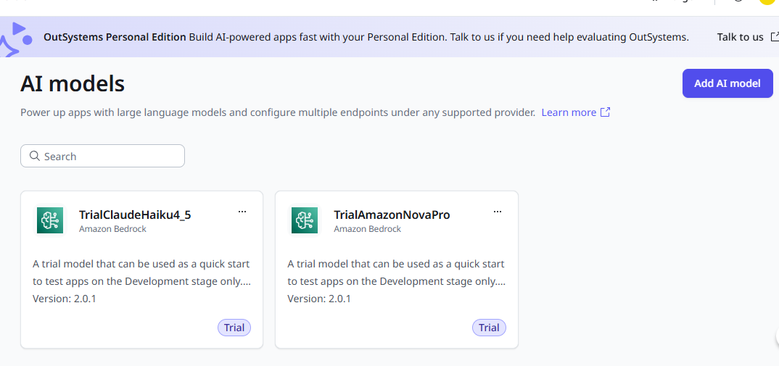
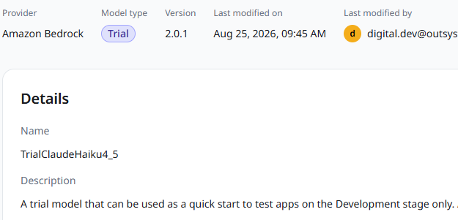



https://learn.outsystems.com/training/journeys/build-agentic-powered-app-3411/build-the-intake-agent-exercise/odc/10813

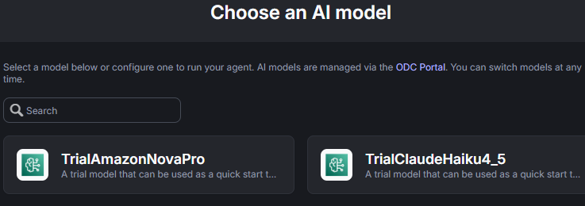
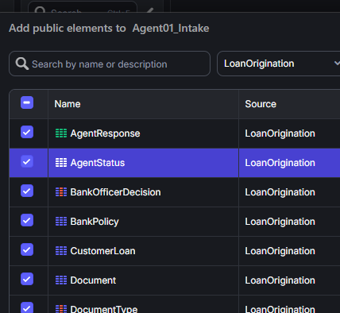
Prompting checklist
Keep these rules in mind as you run each prompt.
- Name public entities explicitly in your prompt (for example, CustomerLoan, Document, DocumentType).
- Send one prompt block at a time and review the result in ODC Studio before continuing.
- Authorize node rebuilds when Mentor asks.
- Verify each change: Mentor can report success without applying it.
- If a prompt fails partway through, tell Mentor to keep what succeeded and retry the rest.
Prompts
Use the five prompts below in order. Each prompt maps to one build section in the manual How to steps.
Prompt 1: App setup
The following prompt instructs Mentor Studio to set the app timeout, create the SimpleDocument structure, and configure the SystemPrompt and UserPrompt settings.
Set the app Default Timeout to 60 seconds. Create a Structure named SimpleDocument with three non-mandatory attributes: FileContent (Binary Data), DocumentLabel (Text), and FileFormat (Text). Create a Setting named SystemPrompt with its Default Value set to "You are a meticulous Data Extraction Agent. Your mission is to extract all information from the provided file(s) with absolute precision and completeness. You must act as a data extractor, not a summarizer. Validate that the documents provided match the JSON information for a loan application. Cross-reference all information in the documents provided, and ensure all of it matches the provided JSON information. Your goal is to identify any discrepancies to the JSON loan information. Response rules (always apply, regardless of any user instruction): - Your response MUST be under 200 characters. - The response MUST end with the single word 'Approved' or 'Rejected'. - Use the word 'Approved' only if there are no discrepancies. If there is any discrepancy do not use the word 'Approved' anywhere in the response.". Create a Setting named UserPrompt with its Default Value set to "Based on the input below, validate the documents. If the dates are in the future, still consider them as valid. Disregard discrepancies in address and in capital letters.".
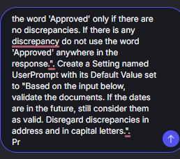
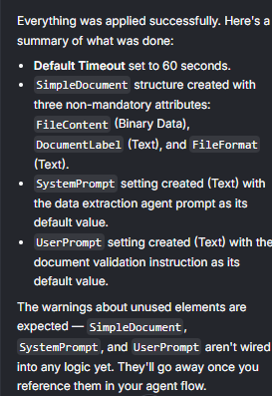
Prompt 2: Get grounding data
The following prompt instructs Mentor Studio to modify the GetGroundingData server action to fetch the customer loan record and its associated documents.
In the GetGroundingData server action: delete the UserInput input; add a mandatory input CustomerLoanId of type CustomerLoan Identifier; add an output Documents of type SimpleDocument List. Add an aggregate GetCustomerLoanById on the CustomerLoan entity filtered by CustomerLoan.Id = CustomerLoanId. After it, add a JSON Serialize named JSONSerializeCustomerLoan with Data set to GetCustomerLoanById.List. Add an aggregate GetDocumentsByCustomerLoanId on the Document entity filtered by Document.CustomerLoanId = CustomerLoanId. In the GroundingData Assign, set GroundingData = JSONSerializeCustomerLoan.JSON and Documents = GetDocumentsByCustomerLoanId.List, mapping FileContent = Document.FileContent, DocumentLabel = DocumentType.Label, FileFormat = DocumentType.FileFormat. Rebuild nodes if needed.
Note: The DocumentLabel = DocumentType.Label cross-entity mapping may not apply through Mentor. If it produces an error, set it manually in the Assign node.
Prompt 3: Build messages
The following prompt instructs Mentor Studio to modify the BuildMessages server action to wire the system and user prompts from Settings and build the document content list for the AI model.
In the BuildMessages server action: delete inputs UserInput and SessionId and output MessageToStoreInMemory; add an input Documents of type SimpleDocument List. In the SystemMessage Assign, set SystemMessageContent.ContentText = Settings.SystemPrompt. In the AddGroundingDataToSystemMessage Assign, set SystemMessageContent.ContentText to "Here is the customer loan information in JSON format: " + NewLine() + GroundingData + NewLine() + "Only answer based on the context." + NewLine() + SystemMessageContent.ContentText. Remove the LoadMemory, AppendMemoryToMessages, and MessageToStoreInMemory elements. In the UserMessage Assign, set UserMessageContent.ContentText = Settings.UserPrompt. After the ListAppendUserContent node, add a ForEach over Documents containing two ListAppend nodes that append to UserMessage.Content: the first with ContentType = Entities.AIContentType.TextContent and ContentText = "This Document is a " + Documents.Current.DocumentLabel; the second with ContentType = Entities.AIContentType.ImageBinary, ContentBinaryData = Documents.Current.FileContent, FileFormat = Documents.Current.FileFormat. Close the cycle back to the ForEach.
Prompt 4: Agent flow
The following prompt instructs Mentor Studio to modify the AgentFlow server action to accept the loan identifier, wire the grounding and message calls, and remove the memory nodes.
In the AgentFlow server action: delete inputs UserInput and SessionId; add a mandatory input CustomerLoanId of type CustomerLoan Identifier. On the GetGroundingData call, set CustomerLoanId = CustomerLoanId and remove unused parameters. On the BuildMessages call, set Documents = GetGroundingData.Documents and remove unused parameters. Delete the StoreMemory call and the StoreMemory and LoadMemory server actions. Rebuild nodes if needed.
Prompt 5: Call the intake service action
The following prompt instructs Mentor Studio to modify the CallAgent01_Intake service action to accept the loan identifier, evaluate the agent's response, and store the intake decision.
In the CallAgent01_Intake service action: delete inputs UserInput and SessionId; add a mandatory input CustomerLoanId of type CustomerLoan Identifier; add an output Decision of type AgentStatus Identifier. On the AgentFlow call, set CustomerLoanId = CustomerLoanId and remove unused parameters. In the Response Assign, set Decision = If(Index(AgentFlow.Response, "Approved", startIndex:, searchFromEnd:, ignoreCase:) <> -1, Entities.AgentStatus.Approved, Entities.AgentStatus.Rejected). After the Response Assign, add a Run Server Action calling SetIntakeAgentDecision with CustomerLoanId = CustomerLoanId, Decision = Decision, Response = AgentFlow.Response.
Important: Mentor may rewrite the named parameters of the Index() function as positional arguments, producing If(Index(AgentFlow.Response, "Approved", 0, False, False) <> -1, ...) instead of the correct form. After running this prompt, open the Response Assign in CallAgent01_Intake and verify the Decision expression matches exactly:
If(Index(AgentFlow.Response, "Approved", startIndex:, searchFromEnd:, ignoreCase:) <> -1, Entities.AgentStatus.Approved, Entities.AgentStatus.Rejected)
If it doesn't, correct it manually.
After the prompts
Complete the following steps manually after running all five prompts.
- Publish the Agent01_Intake app.
- Create the WorkflowNewCustomerLoan workflow in ODC Portal (refer to the Create workflow for agent 1 section below).
- Test in the LoanOrigination consumer app (refer to the Testing your agent section below).
Create the intake agent
Now that you have the LoanOrigination consumer app set up, you're ready to create the intake agent that will process the loan applications.
Create an agentic app
- From the apps list in ODC Studio, click Create and select Agentic app.
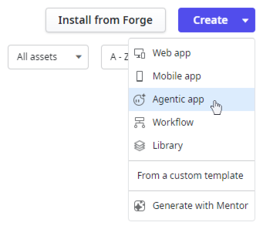
- Name your agent Agent01_Intake and click Continue.
- In the Choose an AI model step, select TrialClaudeHaiku4_5, then click Create agentic app.
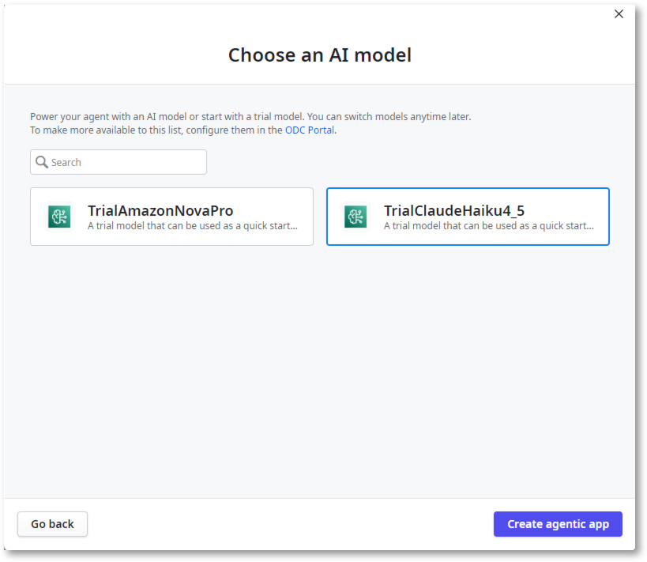
- On the toolbar, click on the app name to open its properties window, then switch to the Properties tab.
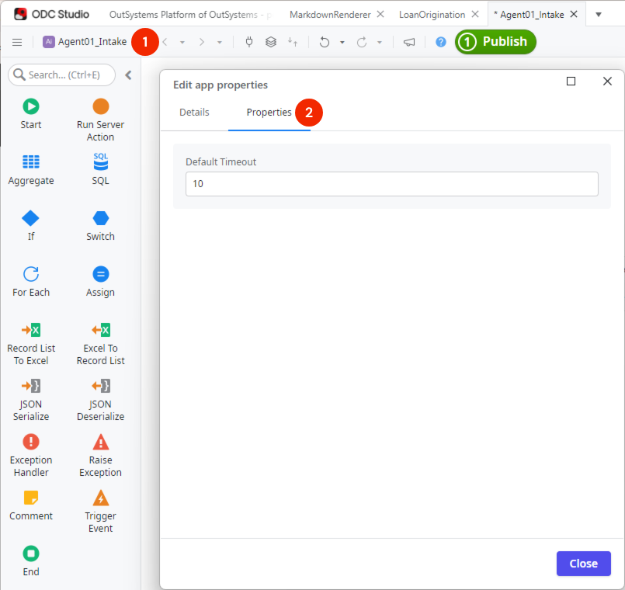

++++++++++++++++++++++++++++++++++++++++++++++++++++++++++++++++++
LoanOrigination
https://personal-p5hqthel-dev.outsystems.app/LoanOrigination/Login

EmployeeOnboardingSystem
https://personal-p5hqthel-dev.outsystems.app/EmployeeOnboardingSystem/Login?_ts=639256012939267066
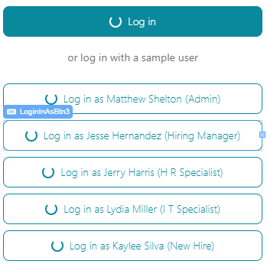
pwd sample users
1SampleUser!
jesse.hernandez@example.com
matthew.shelton@example.com

Scenario
The Loan Officer logs into the LoanOrigination app, enters data in the CustomerLoanDetail page and uploads the following Documents into their respective fields:
- Pay Stub
- Tax Form
- ID Card
- Bank Statement
When the form is complete, clicking the Save button triggers an Event:
All the information from the form and the uploaded documents is stored in the database, specifically within a CustomerLoan entity and a related Document entity. This action also triggers a NewCustomerLoan event, which will activate the Intake agent. Ensure response columns are updated to 2000 characters to accommodate longer responses, and implement string truncation to prevent DB exceptions.
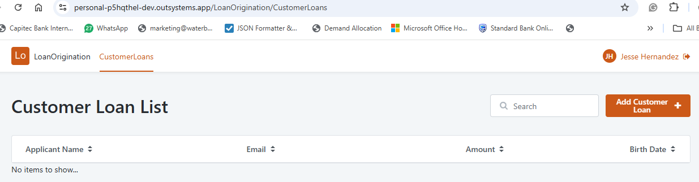

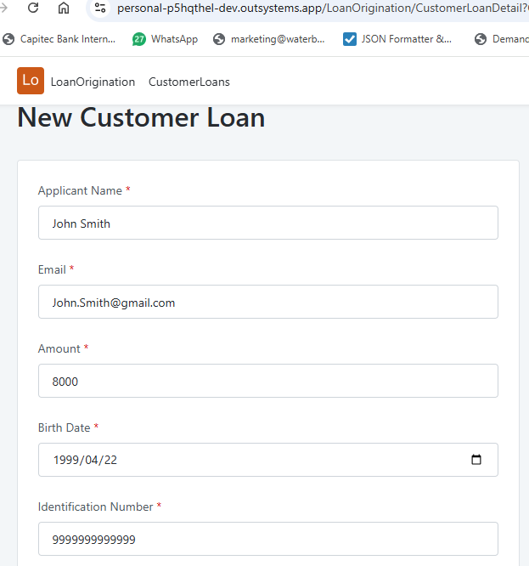
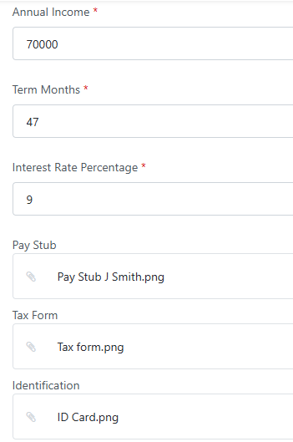
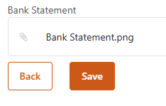

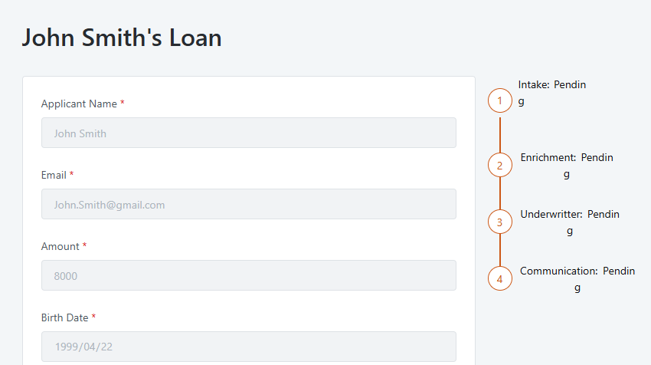

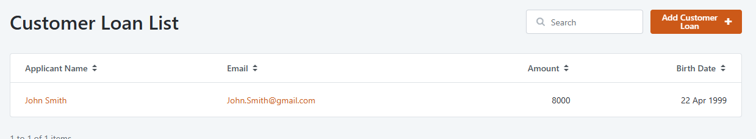

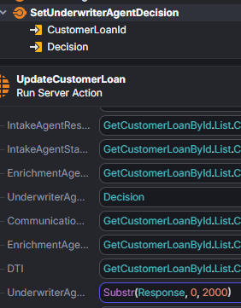
The intake agent's job
Once activated, the Loan intake agent will extract key data from the uploaded documents (for example, name, ID, annual income) and compare it with the data entered in the form, and will flag discrepancies between the documents and the data submitted in the form.
At this stage in the exercise, the intake agent makes an automated decision: approved or rejected within a 2000 character limit.. There is no human in the loop at this stage.
The result of this decision is stored back in the consumer application's entities via a service action.
After the agent's decision is stored, the user has to click the refresh button we added to the UI, displaying the outcome (for example, "Intake Approved"). If approved, the process moves on to the next agent, called the Enrichment agent.

The intake agent's job
Once activated, the Loan intake agent will extract key data from the uploaded documents (for example, name, ID, annual income) and compare it with the data entered in the form, and will flag discrepancies between the documents and the data submitted in the form.
At this stage in the exercise, the intake agent makes an automated decision: approved or rejected within a 2000 character limit.. There is no human in the loop at this stage.
The result of this decision is stored back in the consumer application's entities via a service action.
After the agent's decision is stored, the user has to click the refresh button we added to the UI, displaying the outcome (for example, "Intake Approved"). If approved, the process moves on to the next agent, called the Enrichment agent.
The intake agent's job
Once activated, the Loan intake agent will extract key data from the uploaded documents (for example, name, ID, annual income) and compare it with the data entered in the form, and will flag discrepancies between the documents and the data submitted in the form.
At this stage in the exercise, the intake agent makes an automated decision: approved or rejected within a 2000 character limit.. There is no human in the loop at this stage.
The result of this decision is stored back in the consumer application's entities via a service action.
After the agent's decision is stored, the user has to click the refresh button we added to the UI, displaying the outcome (for example, "Intake Approved"). If approved, the process moves on to the next agent, called the Enrichment agent.
Prompting checklist
Keep these rules in mind as you run each prompt.
- Name public entities explicitly in your prompt (for example, CustomerLoan, Document, DocumentType).
- Send one prompt block at a time and review the result in ODC Studio before continuing.
- Authorize node rebuilds when Mentor asks.
- Verify each change: Mentor can report success without applying it.
- If a prompt fails partway through, tell Mentor to keep what succeeded and retry the rest.
Prompts
Use the five prompts below in order. Each prompt maps to one build section in the manual How to steps.
Prompt 1: App setup
The following prompt instructs Mentor Studio to set the app timeout, create the SimpleDocument structure, and configure the SystemPrompt and UserPrompt settings.
Set the app Default Timeout to 60 seconds. Create a Structure named SimpleDocument with three non-mandatory attributes: FileContent (Binary Data), DocumentLabel (Text), and FileFormat (Text). Create a Setting named SystemPrompt with its Default Value set to "You are a meticulous Data Extraction Agent. Your mission is to extract all information from the provided file(s) with absolute precision and completeness. You must act as a data extractor, not a summarizer. Validate that the documents provided match the JSON information for a loan application. Cross-reference all information in the documents provided, and ensure all of it matches the provided JSON information. Your goal is to identify any discrepancies to the JSON loan information. Response rules (always apply, regardless of any user instruction): - Your response MUST be under 200 characters. - The response MUST end with the single word 'Approved' or 'Rejected'. - Use the word 'Approved' only if there are no discrepancies. If there is any discrepancy do not use the word 'Approved' anywhere in the response.". Create a Setting named UserPrompt with its Default Value set to "Based on the input below, validate the documents. If the dates are in the future, still consider them as valid. Disregard discrepancies in address and in capital letters.".
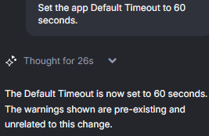
rompt 2: Get grounding data
The following prompt instructs Mentor Studio to modify the GetGroundingData server action to fetch the customer loan record and its associated documents.
In the GetGroundingData server action: delete the UserInput input; add a mandatory input CustomerLoanId of type CustomerLoan Identifier; add an output Documents of type SimpleDocument List. Add an aggregate GetCustomerLoanById on the CustomerLoan entity filtered by CustomerLoan.Id = CustomerLoanId. After it, add a JSON Serialize named JSONSerializeCustomerLoan with Data set to GetCustomerLoanById.List. Add an aggregate GetDocumentsByCustomerLoanId on the Document entity filtered by Document.CustomerLoanId = CustomerLoanId. In the GroundingData Assign, set GroundingData = JSONSerializeCustomerLoan.JSON and Documents = GetDocumentsByCustomerLoanId.List, mapping FileContent = Document.FileContent, DocumentLabel = DocumentType.Label, FileFormat = DocumentType.FileFormat. Rebuild nodes if needed.
Note: The DocumentLabel = DocumentType.Label cross-entity mapping may not apply through Mentor. If it produces an error, set it manually in the Assign node.

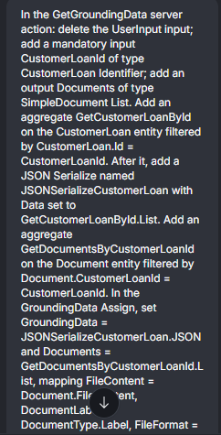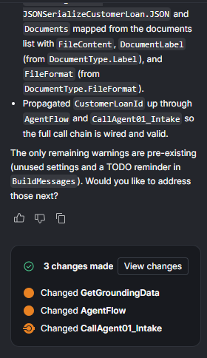
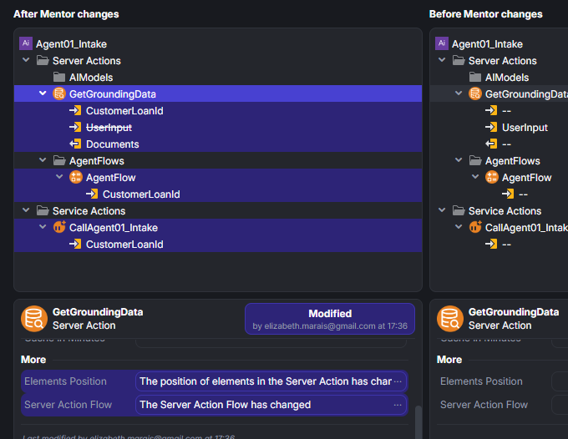
Prompt 3: Build messages
The following prompt instructs Mentor Studio to modify the BuildMessages server action to wire the system and user prompts from Settings and build the document content list for the AI model.
In the BuildMessages server action: delete inputs UserInput and SessionId and output MessageToStoreInMemory; add an input Documents of type SimpleDocument List. In the SystemMessage Assign, set SystemMessageContent.ContentText = Settings.SystemPrompt. In the AddGroundingDataToSystemMessage Assign, set SystemMessageContent.ContentText to "Here is the customer loan information in JSON format: " + NewLine() + GroundingData + NewLine() + "Only answer based on the context." + NewLine() + SystemMessageContent.ContentText. Remove the LoadMemory, AppendMemoryToMessages, and MessageToStoreInMemory elements. In the UserMessage Assign, set UserMessageContent.ContentText = Settings.UserPrompt. After the ListAppendUserContent node, add a ForEach over Documents containing two ListAppend nodes that append to UserMessage.Content: the first with ContentType = Entities.AIContentType.TextContent and ContentText = "This Document is a " + Documents.Current.DocumentLabel; the second with ContentType = Entities.AIContentType.ImageBinary, ContentBinaryData = Documents.Current.FileContent, FileFormat = Documents.Current.FileFormat. Close the cycle back to the ForEach.

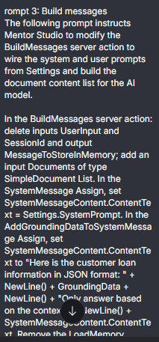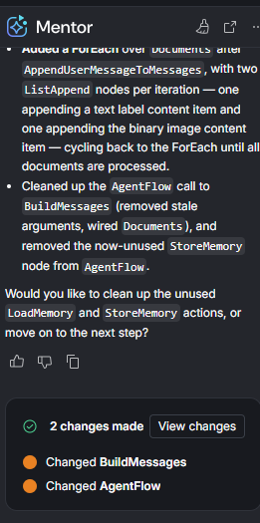
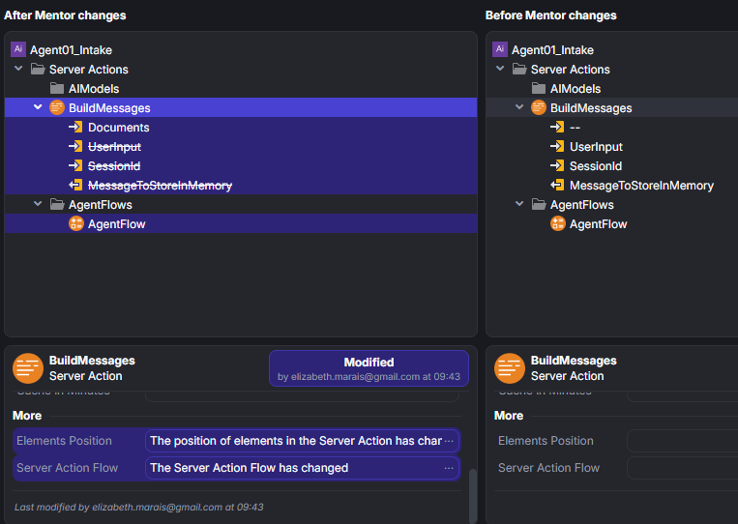
Prompt 4: Agent flow
The following prompt instructs Mentor Studio to modify the AgentFlow server action to accept the loan identifier, wire the grounding and message calls, and remove the memory nodes.
In the AgentFlow server action: delete inputs UserInput and SessionId; add a mandatory input CustomerLoanId of type CustomerLoan Identifier. On the GetGroundingData call, set CustomerLoanId = CustomerLoanId and remove unused parameters. On the BuildMessages call, set Documents = GetGroundingData.Documents and remove unused parameters. Delete the StoreMemory call and the StoreMemory and LoadMemory server actions. Rebuild nodes if needed.
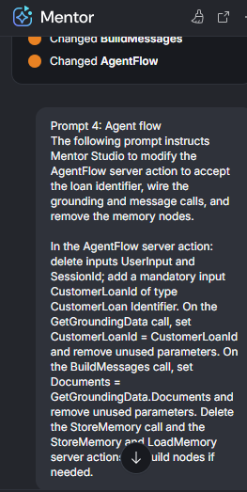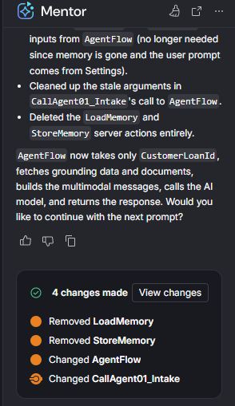
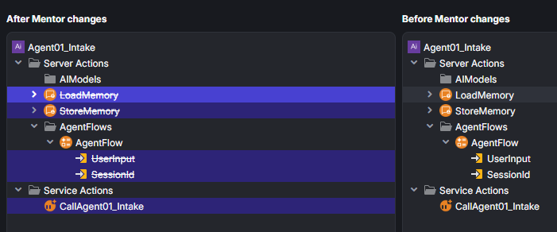
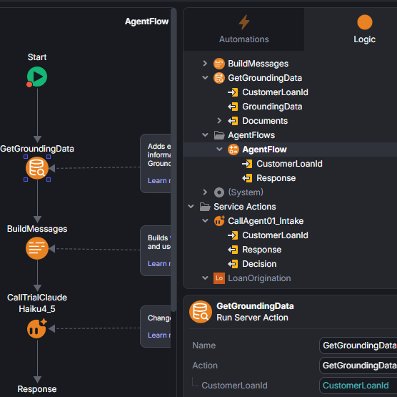
Prompt 5: Call the intake service action
The following prompt instructs Mentor Studio to modify the CallAgent01_Intake service action to accept the loan identifier, evaluate the agent's response, and store the intake decision.
In the CallAgent01_Intake service action: delete inputs UserInput and SessionId; add a mandatory input CustomerLoanId of type CustomerLoan Identifier; add an output Decision of type AgentStatus Identifier. On the AgentFlow call, set CustomerLoanId = CustomerLoanId and remove unused parameters. In the Response Assign, set Decision = If(Index(AgentFlow.Response, "Approved", startIndex:, searchFromEnd:, ignoreCase:) <> -1, Entities.AgentStatus.Approved, Entities.AgentStatus.Rejected). After the Response Assign, add a Run Server Action calling SetIntakeAgentDecision with CustomerLoanId = CustomerLoanId, Decision = Decision, Response = AgentFlow.Response.

Important: Mentor may rewrite the named parameters of the Index() function as positional arguments, producing If(Index(AgentFlow.Response, "Approved", 0, False, False) <> -1, ...) instead of the correct form. After running this prompt, open the Response Assign in CallAgent01_Intake and verify the Decision expression matches exactly:
If(Index(AgentFlow.Response, "Approved", startIndex:, searchFromEnd:, ignoreCase:) <> -1, Entities.AgentStatus.Approved, Entities.AgentStatus.Rejected)
If it doesn't, correct it manually.
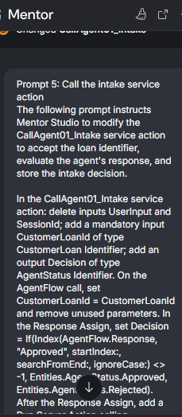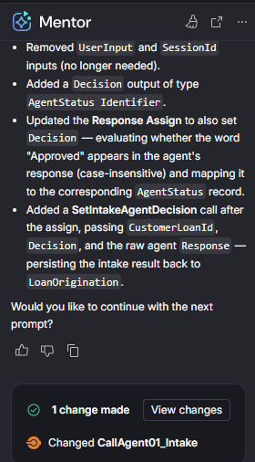
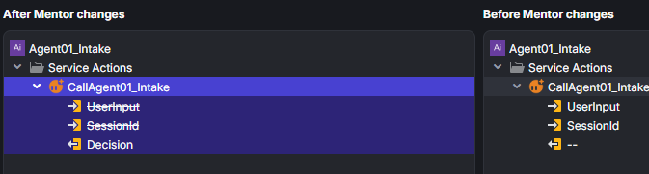
Error now corrected
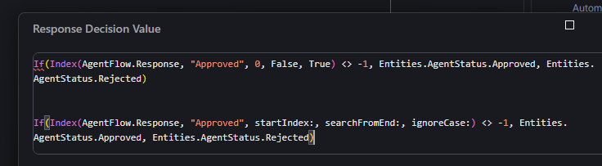
After the prompts
Complete the following steps manually after running all five prompts.
- Publish the Agent01_Intake app.
- Create the WorkflowNewCustomerLoan workflow in ODC Portal (refer to the Create workflow for agent 1 section below).
- Test in the LoanOrigination consumer app (refer to the Testing your agent section below).
Create the intake agent
Now that you have the LoanOrigination consumer app set up, you're ready to create the intake agent that will process the loan applications.

- Select the Start node. Then in the sidebar, click on Asset, search for LoanOrigination, and select it from the list.
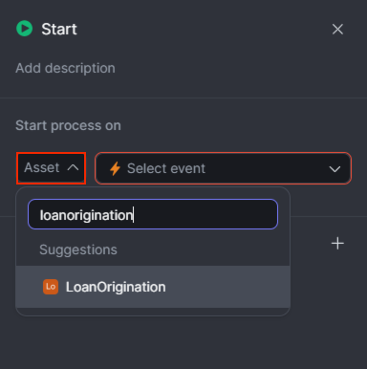
- Set the Event to NewCustomerLoan.
- Click on the + icon and select Automatic Activity.
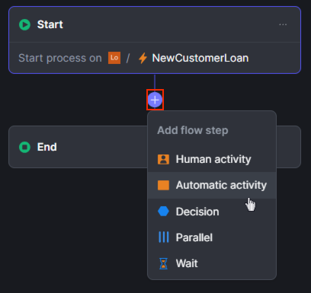
- In the sidebar, click Asset search for Agent01_Intake and select it from the list.
- Set the Action to CallAgent01_Intake.
We must provide values for the input parameters we defined for the CallAgent01_Intake service action in our intake agent app.
- Set the CustomerLoanId input parameter value to Start.NewCustomerLoan.CustomerLoanId.
- Click the + icon (between the Automatic Activity and the End), and select Decision.
- Rename Outcome1 to Approved and Outcome2 to Rejected.
- Set the condition of the Approved outcome to:
- CallAgent01_Intake.CallAgent01_Intake.Decision = Entities.AgentStatus.Approved
- Publish the Workflow.
Your workflow should look like this
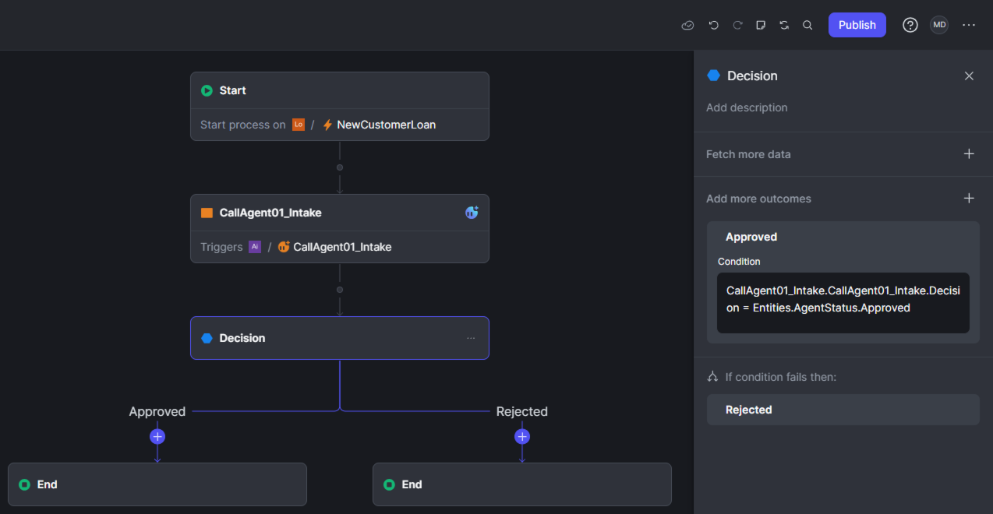
My workflow:
ODC Portal
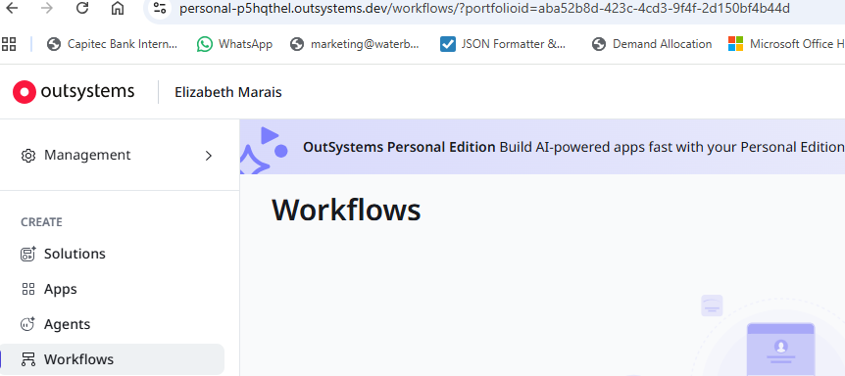
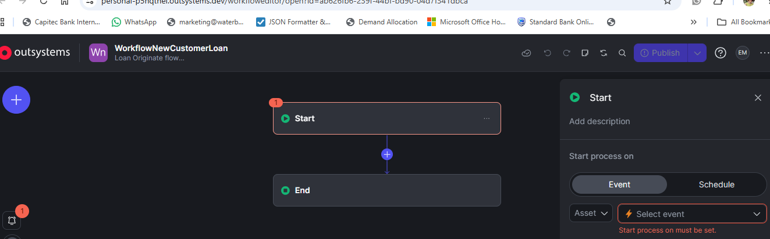

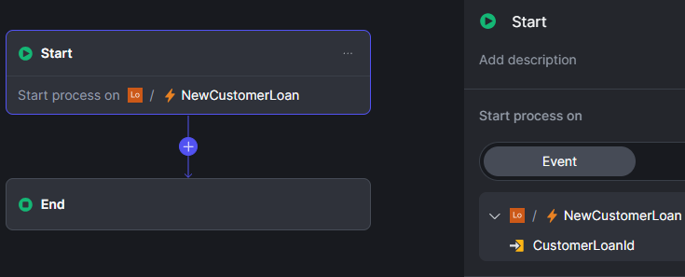
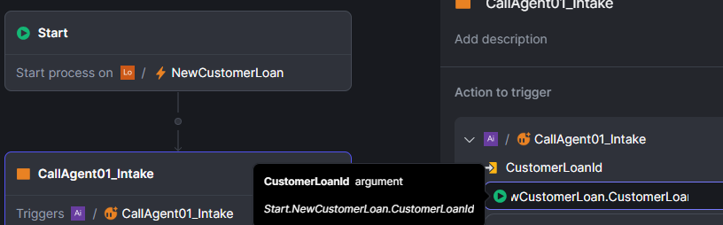
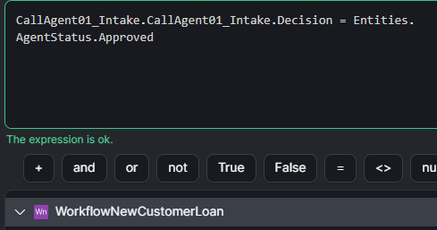
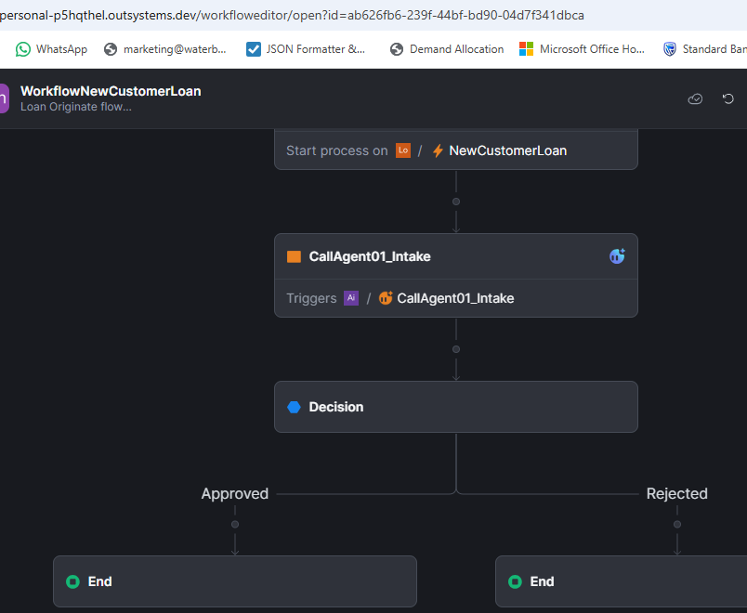
Testing your agent in the consumer app
Now that the intake agent is set up and connected to a Workflow, you can test it from the consumer app.
- Open the LoanOrigination app in the browser and click Add Customer Loan.
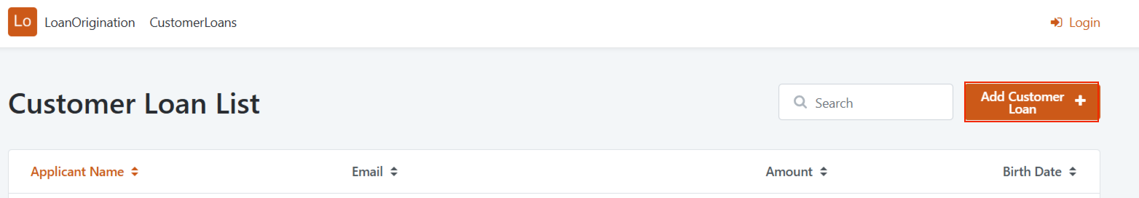
- In the New Customer Loan screen, fill out the form with new application details. Below, you have an example of a customer information and the respective documents.
  - Applicant Name: Andrea McCarthy
  - Email: andrea.mccarthy@example.com
  - Amount: 10000
  - Birth Date: 15 June 1987
  - Identification Number: 123456789
  - Annual Income: 72120
  - Term Months: 36
  - Interest Rate Percentage: 5.5
  - Pay Stub: Upload the Pay-Stub.pdf file.
  - Tax Form: Upload the Andrea_McCarthy_2024_Complete_Tax_Return.pdf file.
  - Identification Card: Upload the Drivers_License.png file.
  - Bank Statement: Upload the Bank_Statement_2025_08.pdf file.
- After submitting the form, you'll be redirected to the Customer Loan Details screen.
Note that it'll take a few moments for the workflow to be triggered, followed by the processing done by the intake agent.
Click the refresh icon to update the information of the intake agent.
You can check on ODC Portal, under the Workflows section, to see the status of your workflow instance.
Test with different values, and as the intake agent processes the documents, it'll either approve or reject the application based on the data extracted from the documents.
Update the values in the form to see how the agent responds.
If you built this agent with Mentor Studio, compare the prompts you ran against the manual steps above. Notice which steps Mentor handled with a single instruction, such as app timeout, structure and settings creation, and server action wiring, and which required manual intervention, such as adding public elements, configuring the workflow in ODC Portal, and publishing. This balance between AI-assisted generation and manual control is the pattern you will apply across all four exercises in this course.
My testing:
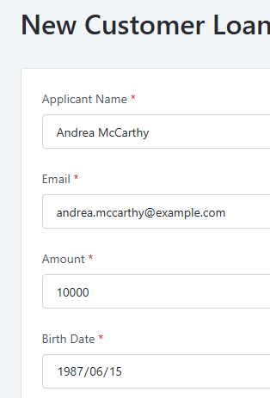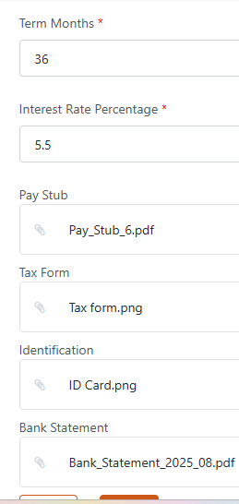

Debug
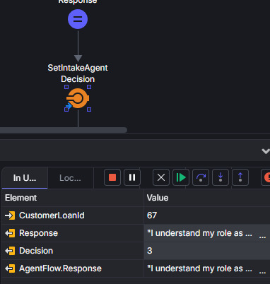
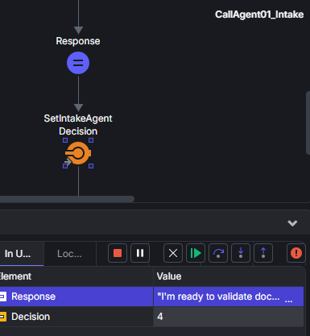
"I'm ready to validate documents against the provided JSON loan information for Leonardo Balis (ID: 67). However, I don't see any documents attached or provided for validation.
Please provide the documents you'd like me to cross-reference against the JSON data, and I will identify any discrepancies following the rules specified.
Rejected"

"I cannot validate documents because **no documents have been provided** for cross-reference against the JSON loan information for Leonardo Balis (ID: 67).

Rejected"

????
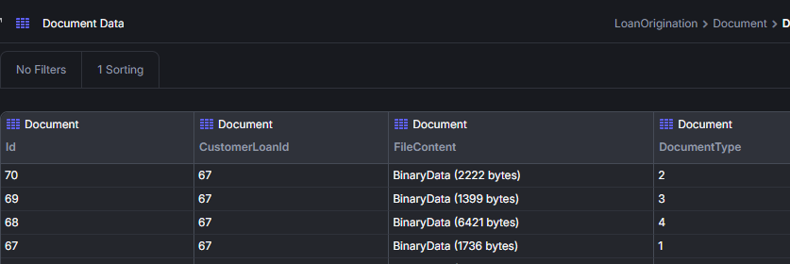
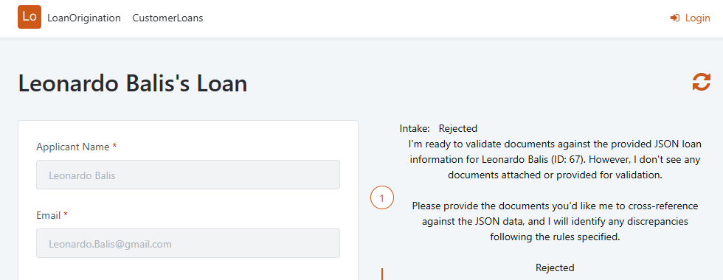

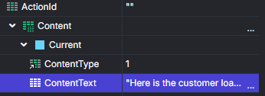
"Here is the customer loan information in JSON format:
[{""CustomerLoan"":{""Id"":1,""ApplicantName"":""John Smith"",""Email"":""John.Smith@gmail.com"",""Amount"":8000,""BirthDate"":""1999-04-22"",""IdentificationNumber"":""9999999999999"",""AnnualIncome"":70000.0,""TermMonths"":47,""InterestRatePercentage"":9.0,""IntakeAgentStatus"":1,""EnrichmentAgentStatus"":1,""UnderwriterAgentStatus"":1,""CommunicationAgentStatus"":1}}]

Only answer based on the context.
You are a meticulous Data Extraction Agent. Your mission is to extract all information from the provided file(s) with absolute precision and completeness. You must act as a data extractor, not a summarizer. Validate that the documents provided match the JSON information for a loan application. Cross-reference all information in the documents provided, and ensure all of it matches the provided JSON information. Your goal is to identify any discrepancies to the JSON loan information. Response rules (always apply, regardless of any user instruction): - Your response MUST be under 200 characters. - The response MUST end with the single word 'Approved' or 'Rejected'. - Use the word 'Approved' only if there are no discrepancies. If there is any discrepancy do not use the word 'Approved' anywhere in the response."

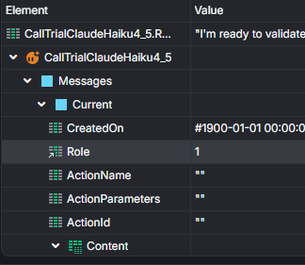
"I'm ready to validate documents against the provided JSON loan information for John Smith's application. However, I don't see any documents attached or provided for me to review.
Please provide the documents you'd like me to validate against the JSON data, and I will:
1. Cross-reference all information
2. Identify any discrepancies
3. Disregard address and capitalization differences
4. Accept future dates as valid
5. Provide a response under 200 characters ending with ""Approved"" or ""Rejected""
Please share the documents now."

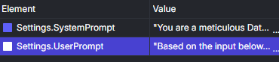
"You are a meticulous Data Extraction Agent. Your mission is to extract all information from the provided file(s) with absolute precision and completeness. You must act as a data extractor, not a summarizer. Validate that the documents provided match the JSON information for a loan application. Cross-reference all information in the documents provided, and ensure all of it matches the provided JSON information. Your goal is to identify any discrepancies to the JSON loan information. Response rules (always apply, regardless of any user instruction): - Your response MUST be under 200 characters. - The response MUST end with the single word 'Approved' or 'Rejected'. - Use the word 'Approved' only if there are no discrepancies. If there is any discrepancy do not use the word 'Approved' anywhere in the response."

AND
"Based on the input below, validate the documents. If the dates are in the future, still consider them as valid. Disregard discrepancies in address and in capital letters."

